**Interactive Random Art Algorithm**

I am building an interactive art platform, where all these paintings are random generated computer arts. On this platform artist can interact with these pre generated arts and can save their state. My motive was to play with the art through hand gestures and to save their state, so that user can build on the top of that. By this platform artists can play with other artist save paintings, which are generated on my application.

This application is build in javascript, and to run this application we need a browser and a webcam. I have used these javascript libraries to build this application:

* p5.min – this is the main library, as it contains all the pre build in javascript to for a drawing app.
* p5.dom.min – this library is used to connect our application with the HTML tags, it helps us to maintain an event based programming methodology.
* ml5.min – the main motive behind using this library is to build hand detection model, this library is build on the top of Tensorflow library, therefore it makes so much easier to build machine learning models through it.

To implement my whole project first I have build 5 random art algorithms (so that user can play with their parameters and can save their state):

Art 1 is “sin-cos movement of circle”:

This art generated a random number of ellipse across the canvas with some random color value and then all the tiny-tiny ellipse points moves in a flow direction using trigonometry functions. These ellipse points and hits the border of the canvas then goes back in the opposite direction.

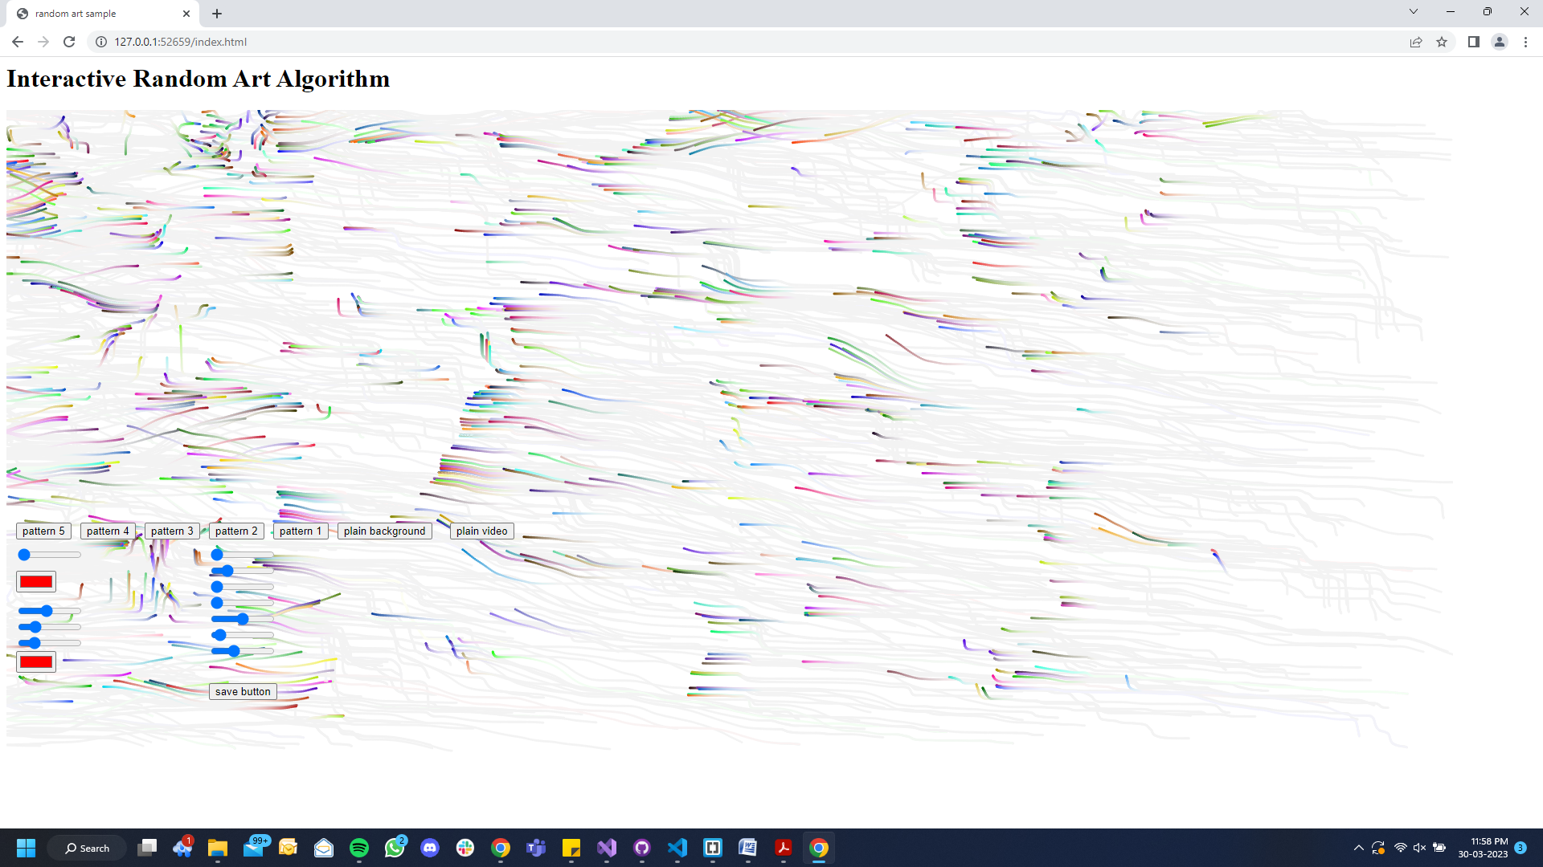

Here user can interact with two parameters, one is the size of circle and another one is the speed of their movement (this speed parameter is directly changing the sin-cos multiplier).

To build this pattern I have made one separate file naming art_1.js, this file contains one main constructor function and inside it there is a few public variable (so that can change over the time in sketch file) and two public functions, that is draw and move.

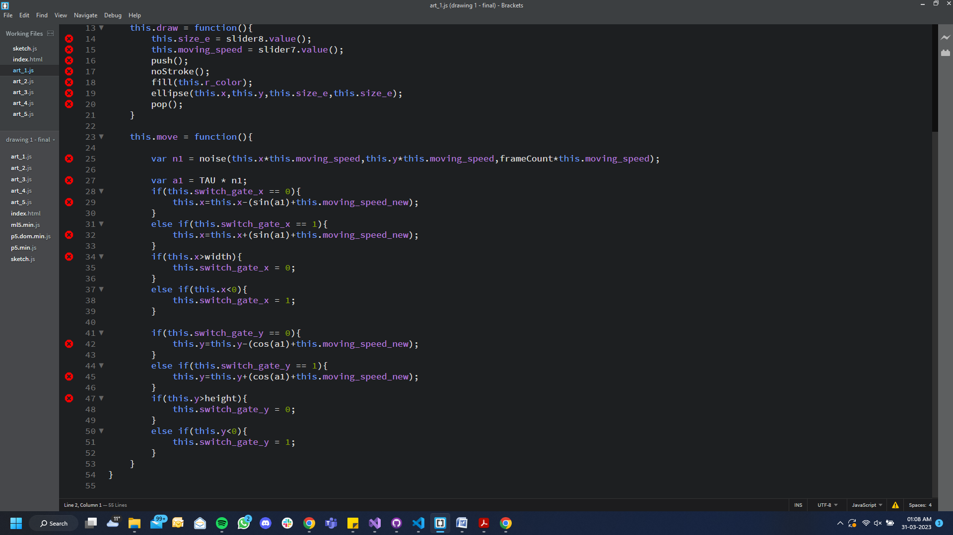

Art 2 is “random square touch interaction”:

This generative art creates a random amount of squares on the screen and with random assigned color, x and y values, here we were able to accomplish overlapping between squares with the help of blendMode function. Half of the squares are having hard light blend and the other half squares are having normal blend.

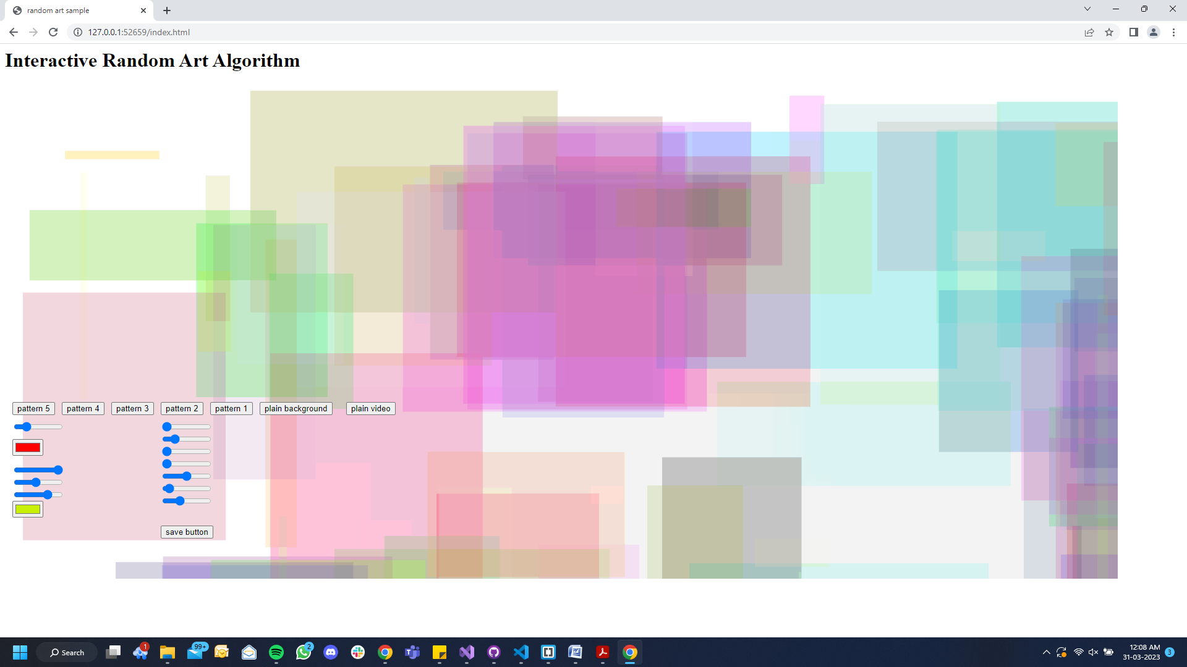

Here, user can interact through 3 features –

* can change the position of square by random touch, means once we move over the squares, those squares will start changing their position randomly.
* Alpha value, user can also select the desired alpha value, so that he/she can play with the color brightness of our squares.
* Use can also play with the square number parameter, that is he/she can control the number of squares on the screen.

To build this pattern I have made one separate file naming art_2.js, this file contains one main constructor function and inside it there is a few public variable (so that can change over the time in sketch file) and two public functions, that is draw and move.

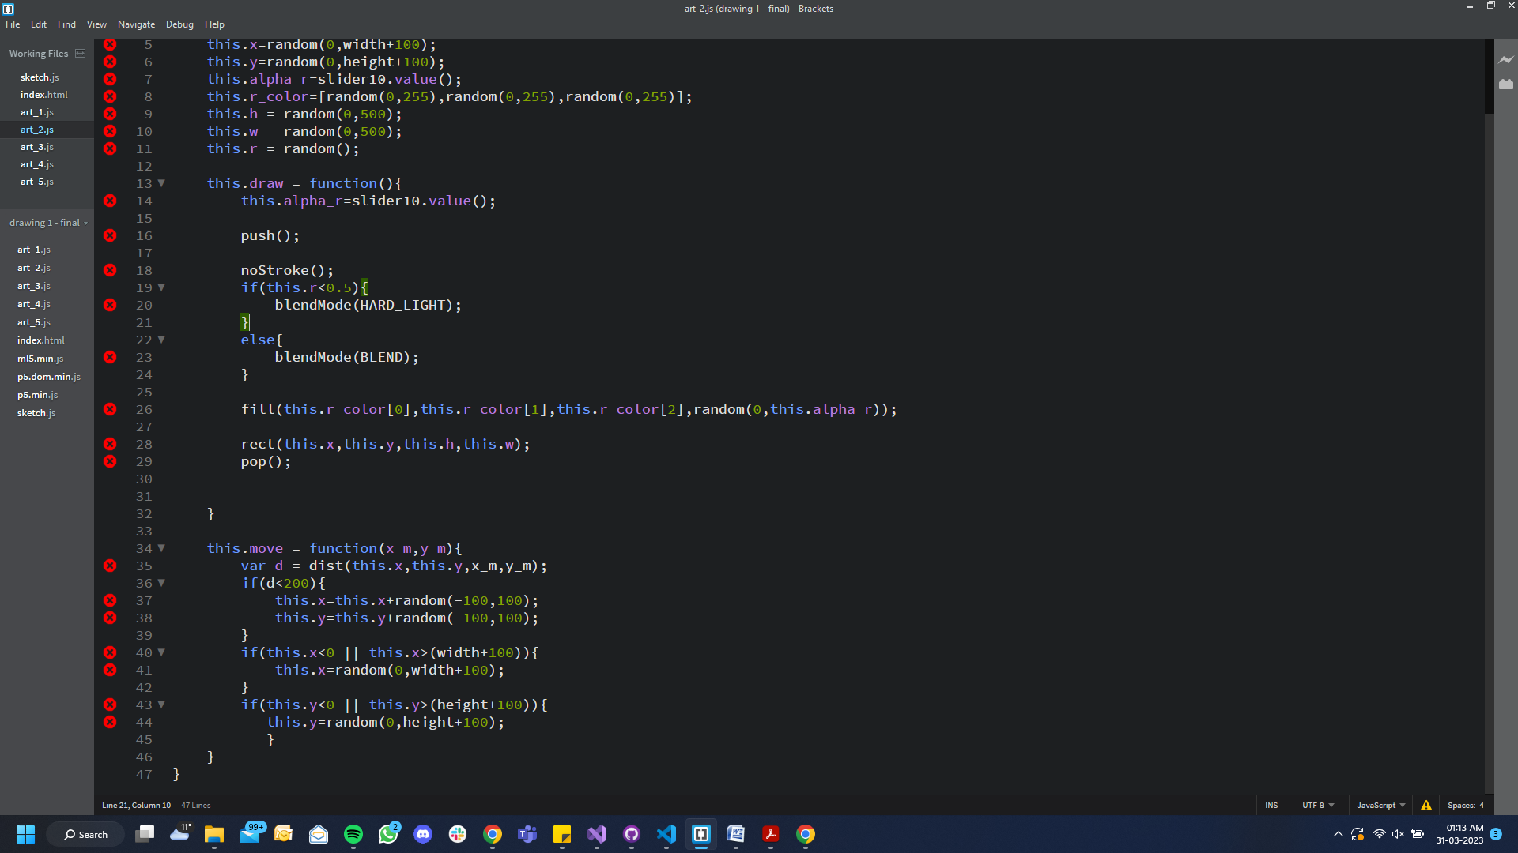

Art 3 is “rotating line pattern”:

This art function allows user to draw a pre build rotating line pattern, user can print as many patterns as he wants and wherever he wants on the canvas. Here user can play with four parameters:

* User can adjust the stroke weight of each pattern and can decide how thick the line should be.
* He/she can also adjust the rotation value parameter, through this parameter we are calculate the pi multiplier of the rotate function.
* we can select the number of lines we wants in a particular pattern, so that we can adjust it according to our stroke weight size.
* And the last parameter is the color of each pattern, user can select a particular color through Color-Picker for any pattern on the screen.

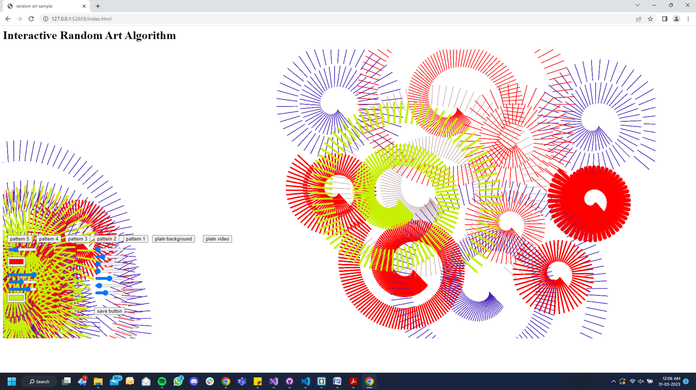

To build this pattern I have made one separate file naming art_3.js, this file contains one main constructor function and inside it there is a few public variable (so that can change over the time in sketch file) and one public functions, i.e draw an, that is draw and move.

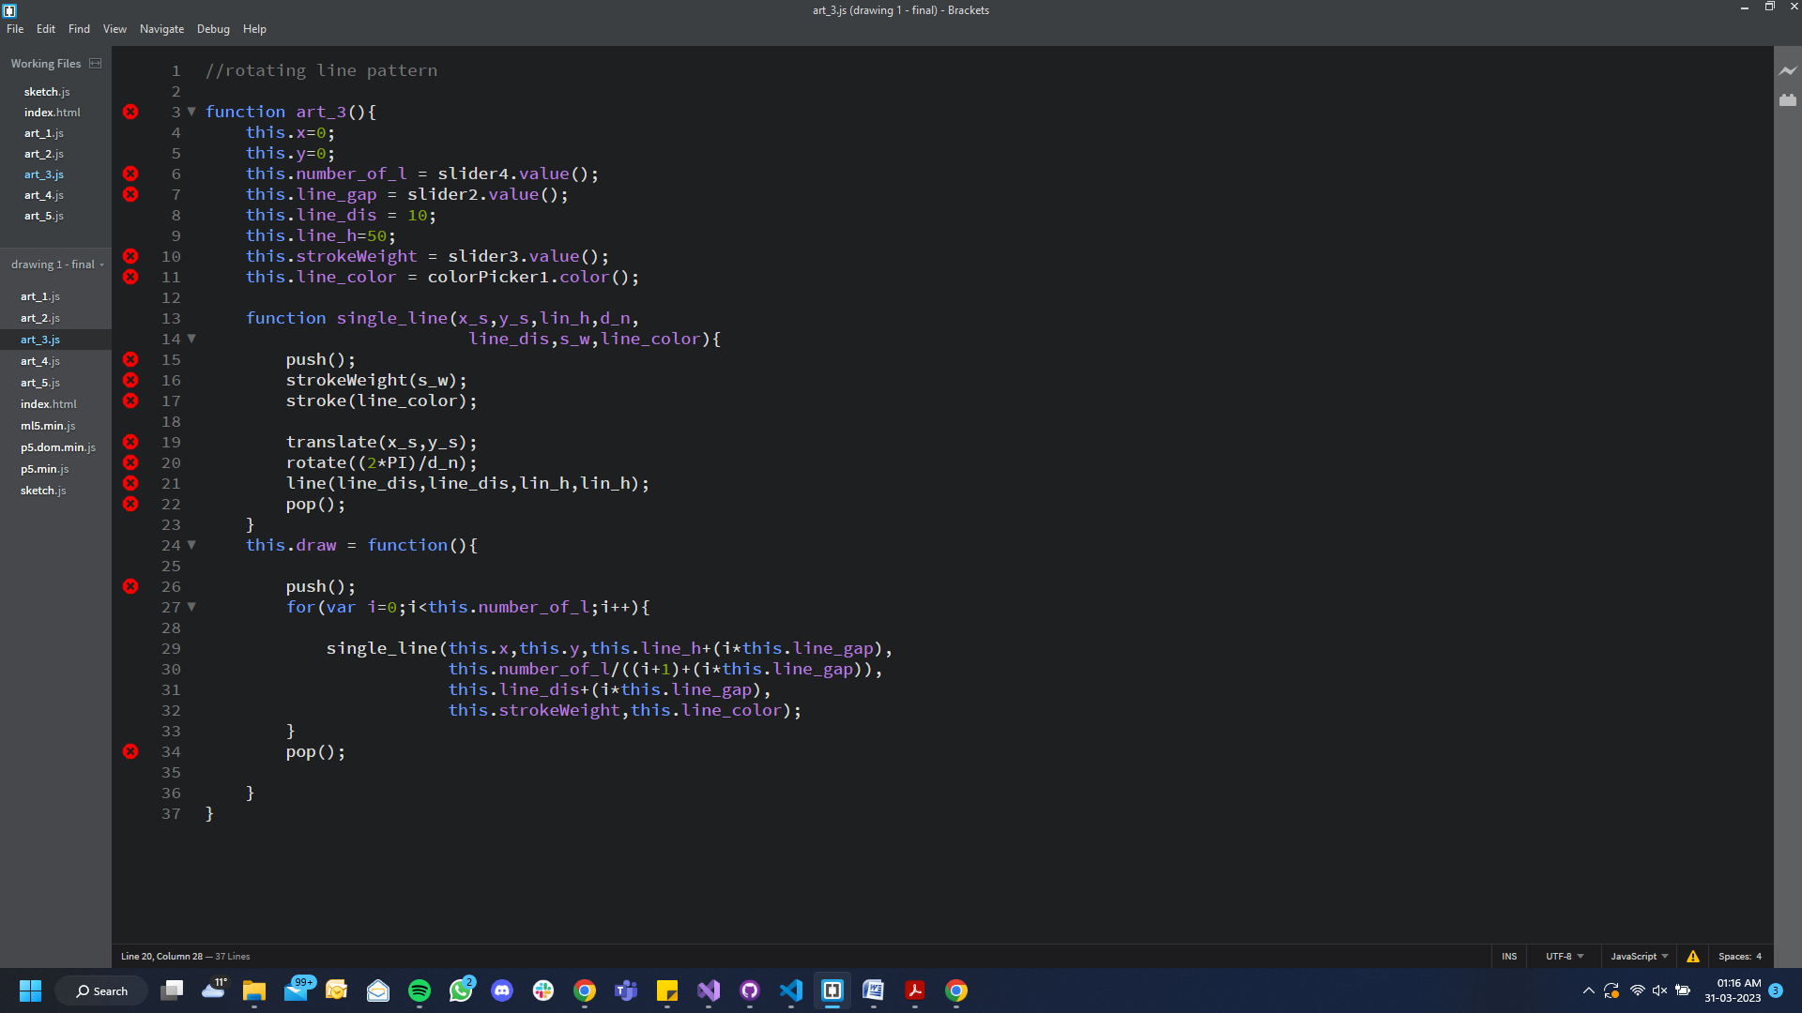

Art 4 is “canvas drawing pen”:

This art form allows user to draw over the screen, he/she can draw anything to over other patterns, here user can just play with our colouring pen anywhere on the canvas. We adjust two things before using the pen, that is the color of the pen and the thickness of the pen.

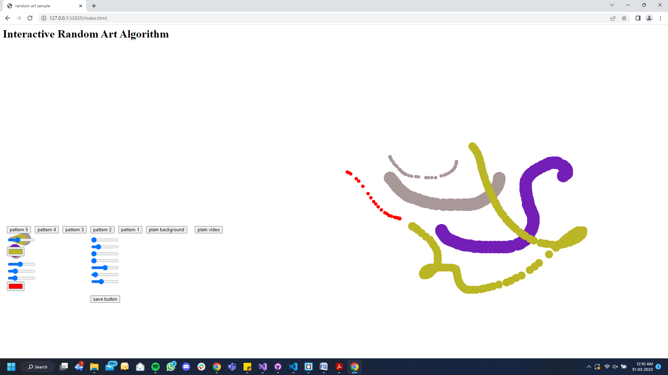

To build this pattern I have made one separate file naming art_4.js, this file contains one main constructor function and inside it there is a few public variable (so that can change over the time in sketch file) and two public functions, that is draw and move.

Art 5 is “colourful doted background”:

This art form generates a grid format of ellipse across the canvas, to build a colourful pattern, in this pattern we can see the color is gradually change from the first ellipse to the last ellipse. Change is color is calculated according to x and y position of each ellipse. Here, user can play with three different types of parameter:

* If user hover over the grid pattern, he/she can see the change in the colour of each ellipse, which is again calculated gradually according the ellipse position.
* Use can change the ellipse size, so that he/she can select the density of these pixels.
* User can also shift between RGB values of fill function, and can pick which corner they want more lighter than the other.

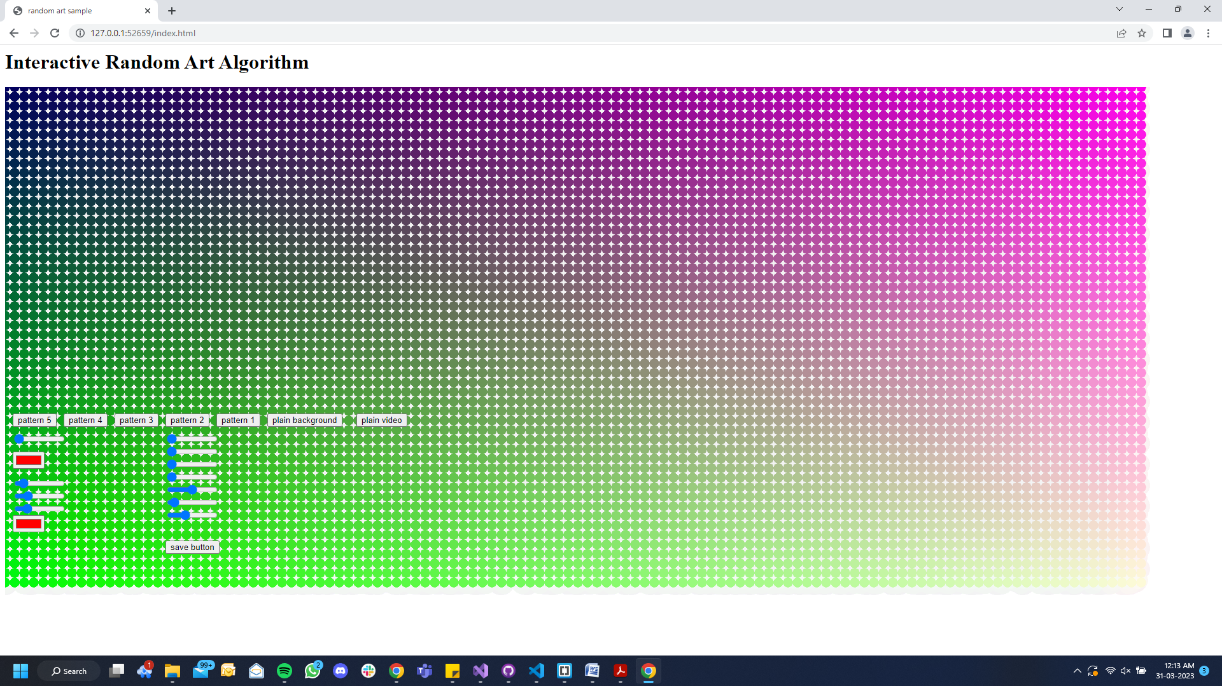

To build this pattern I have made one separate file naming art_5.js, this file contains one main constructor function and inside it there is a few public variable (so that can change over the time in sketch file) and two public functions, that is draw and move.

how you implemented.

Technique , number of functions, how u calling them.

* final implementation (with working code, if appropriate)
* detailed technical description
* how to replicate it
* evaluation and testing

what u were expecting

what could be done more or something else

what u missed / not able to finish

what approach you will use to finish

what have you finised so far

where did u take help from

what were u trying to experiment , it terms of concept and technical parameters. And what was the result.

GitHub repository link ----

https://github.com/rishisankhla/goldsmiths-final-project---interactive-random-art-algorithm.git